Download PowerShell core 7 on the running machines

Perform this lab and provide full desktop screen shots and comment each screen shot. Provide a final summary as to time taken and issues and fixes you may have encountered.

First to check which version of PowerShell we already have: Open PowerShell and run it as an administrator and type in “$PSVersionTable” command, it will show the version we have installed. | 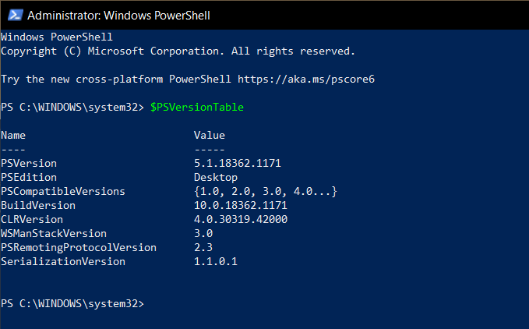
Visit Site:  https://github.com/PowerShell/PowerShell/releases/tag/v7.1.2  To Download PowerShell core 7 on your machine, scroll down and Select “PowerShell-7.1.2-win-x64.msi” for windows 64-bits | 
It will take few seconds to install. Once installed open and click next. | 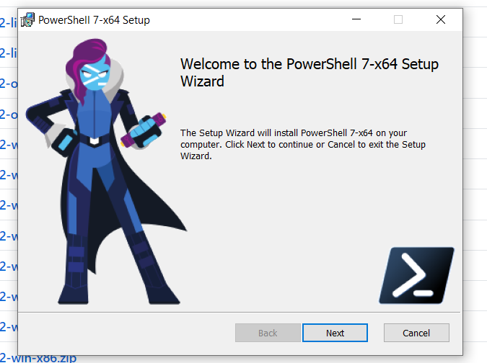
It will ask for destination folder click on change if you want to change the destination folder then click next. | 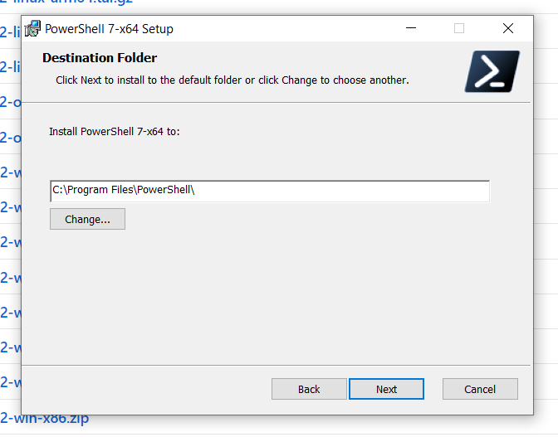
Checkmark the options as shown in the figure then click next. | 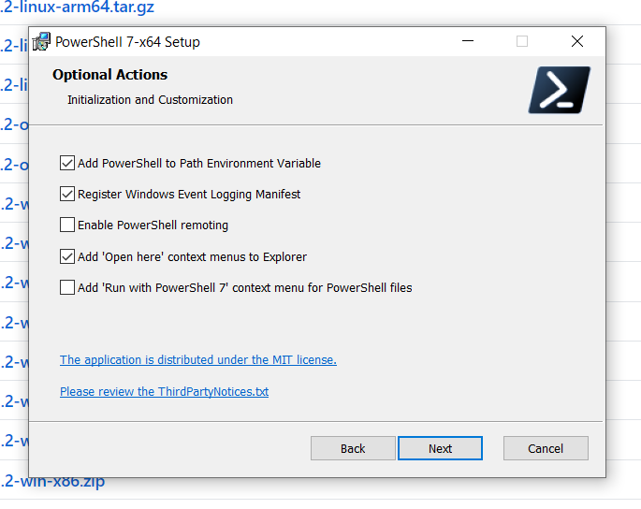
Click on install to begin the installation of PowerShell core 7. | 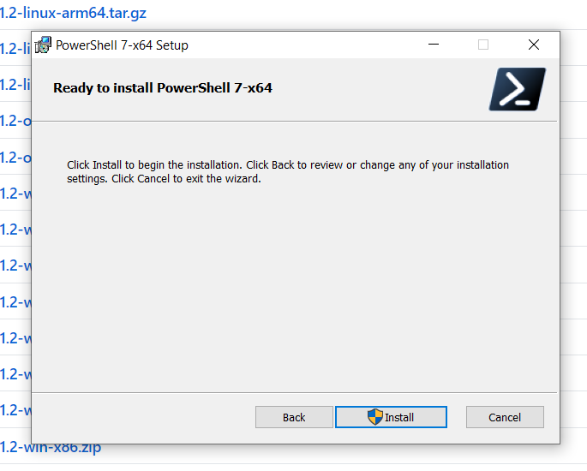
Your PC will ask “Do you want this app to make changes on your computer”, click yes.
Once the installation is done, click on Finish | 